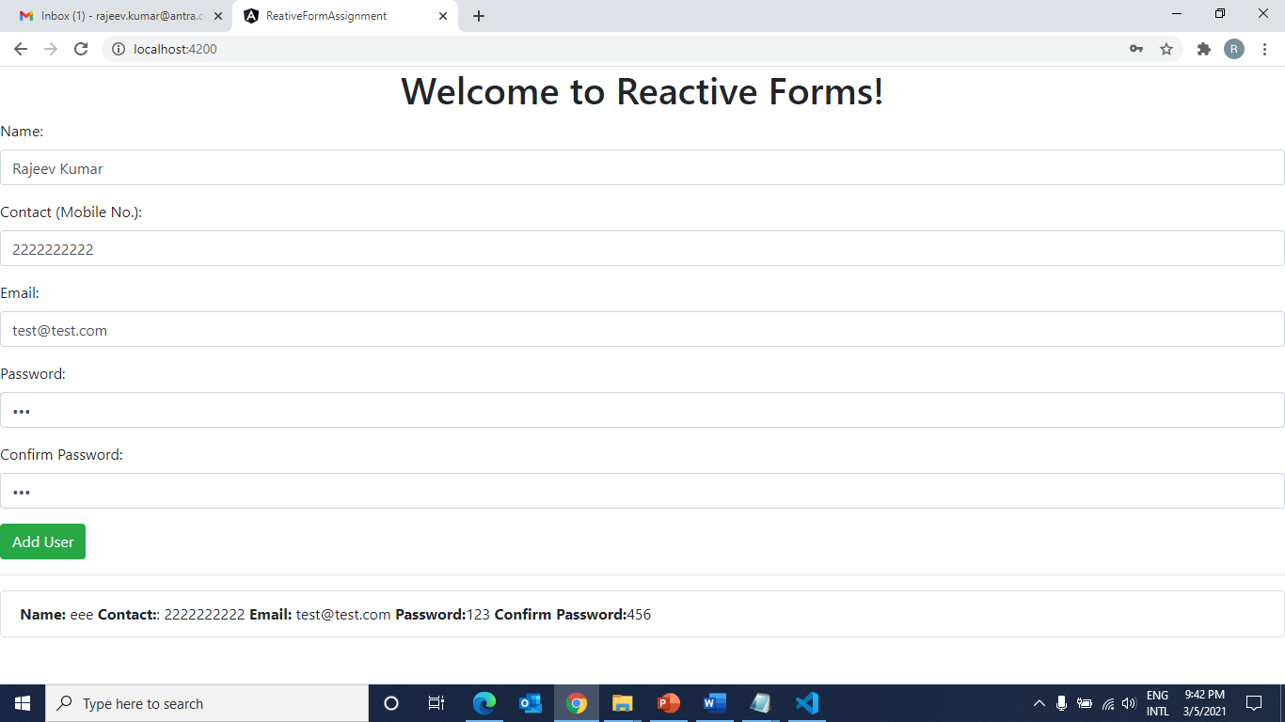

**Note**:

1. Create Reactive form like above.
2. Put required field validation on each form fields.
3. Put custom validation on password and confirm password fields. Means password and confirm password value should be same. Other wise show message like ‘’Confirm password does not match”
4. When user click on Add User button, it show field values enter by user below the Add User button(see screen shot.)